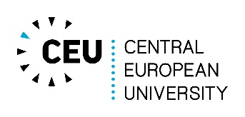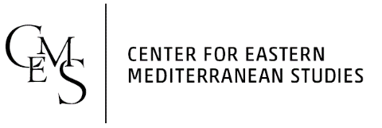

Advanced Certificate Eastern Mediterranean Studies
2016/2017
MA1Y Student Registration
Led by Volker Menze

Name of the student:
Citizenship:
Type of MA studies:
Department:
Title of the MA thesis:
Name of the supervisor:
Date of registration:

Mandatory courses:
Term | Title | Credits
Fall 2016
Winter 2017

 | Total credits | 4
Elective courses:
Term | Title | Credits
Fall 2016
Winter 2017
 | Total credits (min. 8)*

*Source Language credits can be credited to your total elective credits, pending approval from your EMS Supervisor.

Date |  | Head of Certificate

