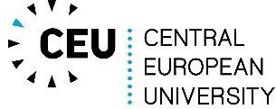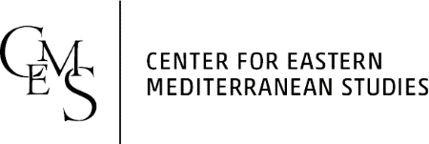

Advanced Certificate Eastern Mediterranean Studies 2025 /2026

MA 1 Y Student Registration

Name of the student:
Citizenship:
Type of MA studies:
Department:
Title of the MA thesis:
Name of the supervisor:
Date of registration:

Courses:
Term | Title | Credits
Fall 2025
Winter 2026
Total credits*
* Source Language credits can be credited to your total credits upon the approval from your EMS Supervisor.

Date |  | Head of Certificate

