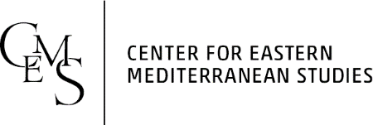

Advanced Certificate Eastern Mediterranean Studies 2022/2023

MA 2 Y Student Registration

Name of the student:
Citizenship:
Type of MA studies:
Department:
Title of the MA thesis:
Name of the supervisor:
Date of registration:

Mandatory courses:

Total credits
Term | Title | Credits
Fall 2022
Winter 2023

Elective courses:
Term | Title | Credits
Fall 2022
Winter 2023
Total credits*
* Source Language credits can be credited to your total elective credits upon the approval from your EMS Supervisor.

Date |  | Head of Certificate

